**IBM Assignment-4**

|  |  |
| --- | --- |
| Team ID | PNT2022TMID52668 |
| Project Name | Smart Waste Management System for Metropolitan Cities |

BATCH:8

HARIPRASATH M 1905083

MEERADEVI S 1905094

SANJAI V 1905111

THENDRAL S 1905119

**Source Code :**

#include <WiFi.h>

#include <PubSubClient.h>

#define ORG "unzyxh"

#define DEVICE_TYPE "ABC"

#define DEVICE_ID "12345"

#define TOKEN "12345678"

char server[] = ORG ".messaging.internetofthings.ibmcloud.com";

char publishTopic[] = "iot-2/evt/UltraSonic_Sensor/fmt/json";

char subscribetopic[] = "iot-2/cmd/command/fmt/String";

char authMethod[] = "use-token-auth";

char token[] = TOKEN;

char clientId[] = "d:" ORG ":" DEVICE_TYPE ":" DEVICE_ID;

void callback(char* subscribetopic, byte* payload, unsigned int payloadLength);

WiFiClient wifiClient; // creating the instance for wificlient

PubSubClient client(server, 1883, wifiClient); //calling the predefined client id by passing parameter like server id,portand wificredential

const int trigPin = 18;

const int echoPin = 5;

long duration;

float distanceCm;

String data3;

void setup()// configureing the ESP32

{

Serial.begin(115200);

pinMode(trigPin, OUTPUT);

pinMode(echoPin, INPUT);

wificonnect();

mqttconnect();

}

void loop()// Recursive Function

{

digitalWrite(trigPin, LOW);

delayMicroseconds(2);

digitalWrite(trigPin, HIGH);

delayMicroseconds(10);

digitalWrite(trigPin, LOW);

duration = pulseIn(echoPin, HIGH);

// Calculate the distance

distanceCm = duration * 0.034/2;

// Prints the distance in the Serial Monitor

Serial.print("Distance (cm): ");

Serial.println(distanceCm);

delay(1000);

if (distanceCm < 100)

{

PublishData(distanceCm);

delay(1000);

if (!client.loop()) {

mqttconnect();

}

}

}

/*.....................................retrieving to Cloud...............................*/

void PublishData(float dist) {

mqttconnect();//function call for connecting to ibm

/*

creating the String in in form JSon to update the data to ibm cloud

*/

String payload = "{\"Distance\":";

payload += dist;

payload += "}";

Serial.print("Sending payload: ");

Serial.println(payload);

if (client.publish(publishTopic, (char*) payload.c_str())) {

Serial.println("Publish ok");// if it sucessfully upload data on the cloud then it will print publish ok in Serial monitor or else it will print publish failed

} else {

Serial.println("Publish failed");

}

}

void mqttconnect() {

if (!client.connected()) {

Serial.print("Reconnecting client to ");

Serial.println(server);

while (!!!client.connect(clientId, authMethod, token)) {

Serial.print(".");

delay(500);

}

Serial.println();

}

}

void wificonnect() //function defination for wificonnect

{

Serial.println();

Serial.print("Connecting to ");

WiFi.begin("Wokwi-GUEST", "", 6);//passing the wifi credentials to establish the connection

while (WiFi.status() != WL_CONNECTED) {

delay(500);

Serial.print(".");

}

Serial.println("");

Serial.println("WiFi connected");

Serial.println("IP address: ");

Serial.println(WiFi.localIP());

}

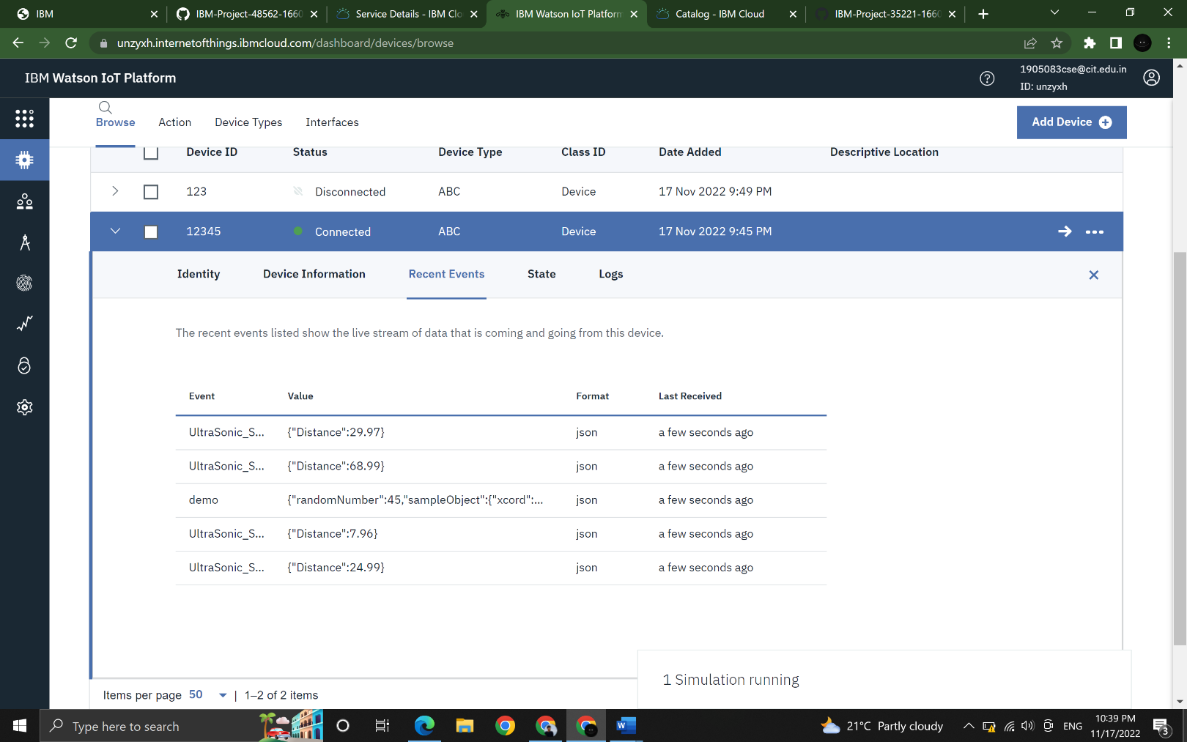**IBM Cloud Outcome:**

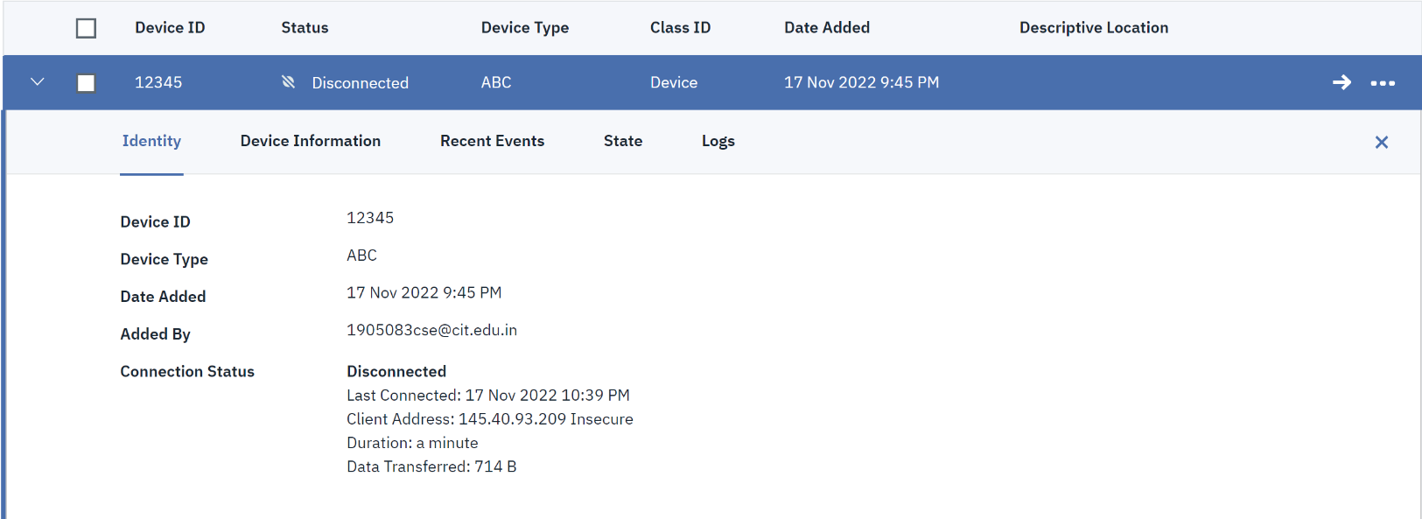**Device details:**

**Stimulator:**

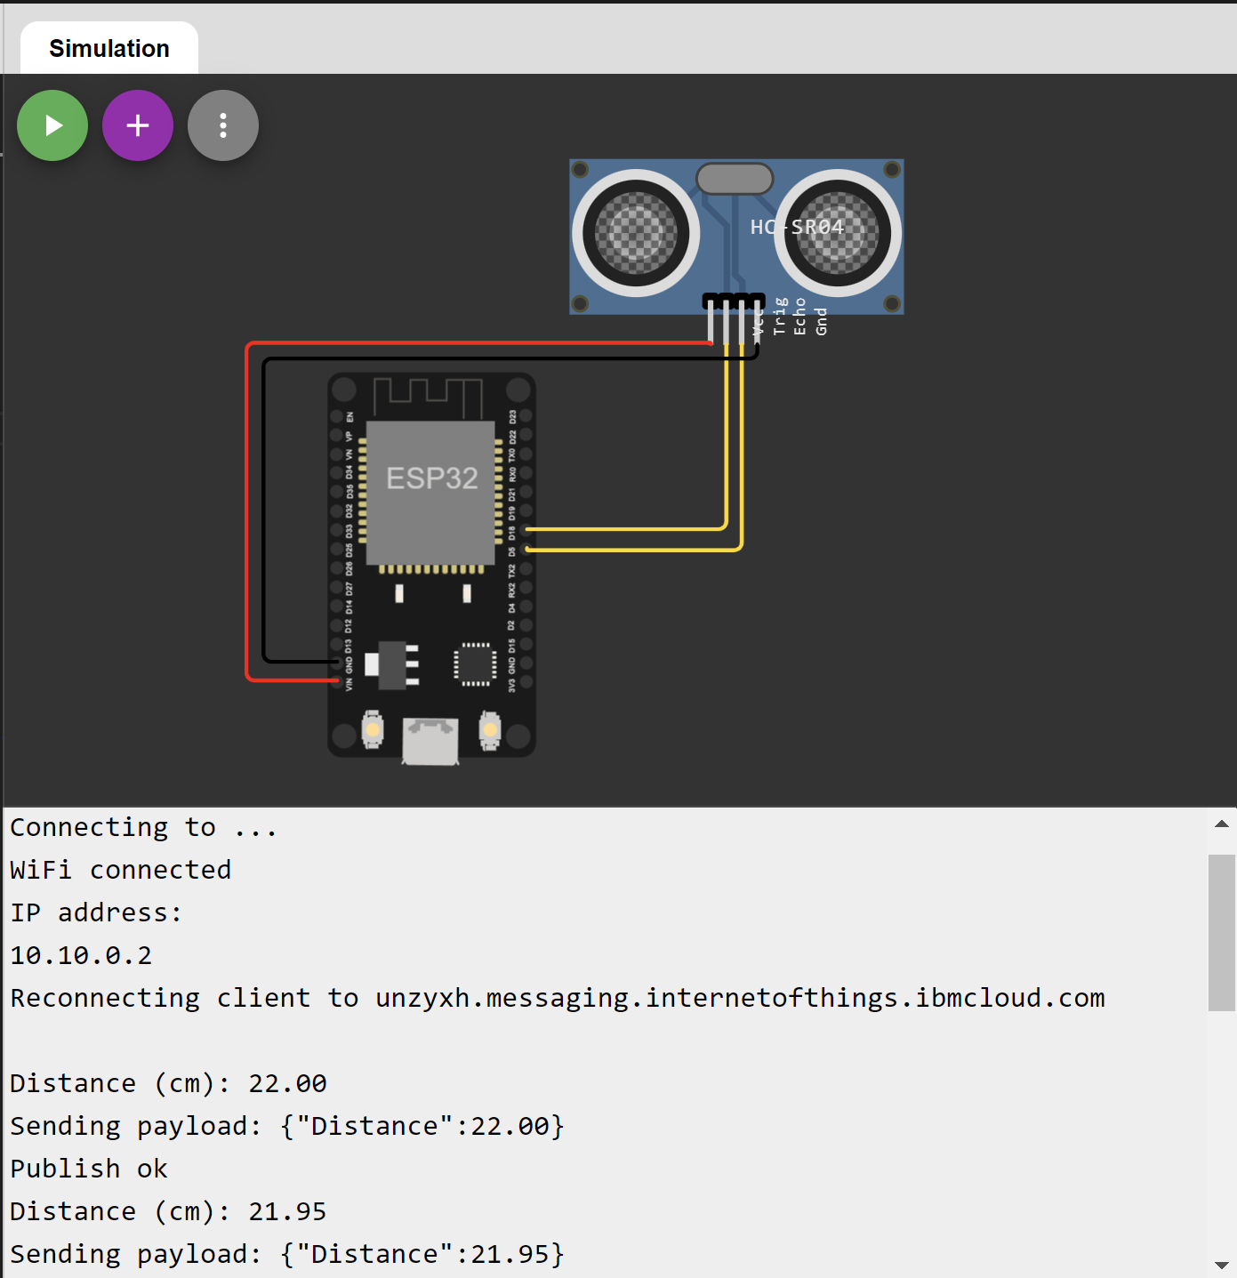

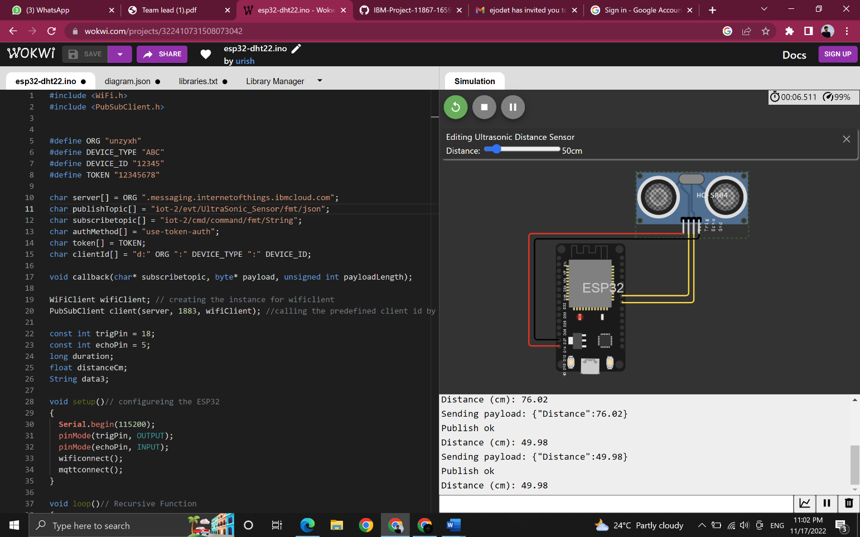**Output:**